Cairo University  
Faculty of Computers and Information



**CS251**

**Software Engineering I**

Project Name

Software Requirements Specifications

Team Names

Month & Year

Contents

Instructions [To be removed] 3

Team 3

Document Purpose and Audience 3

Introduction 3

Software Purpose 3

Software Scope 4

Definitions, acronyms, and abbreviations 4

Requirements 4

Functional Requirements 4

Non Functional Requirements 4

System Models 5

Use Case Model 5

Use Case Tables 5

Ownership Report 6

Policy Regarding Plagiarism: 6

# 

# Team

|  |  |  |  |
| --- | --- | --- | --- |
| **ID** | **Name** | **Email** | **Mobile** |
| 20140226 | Muhammad Rashaad Elsayed | [m_n200854@yahoo.com](mailto:m_n200854@yahoo.com) | 01027386473 |
| 20140025 | Ahmed Sherif Zain | Ahmedsherif95@gmail.com | 01095595744 |
|  |  |  |  |

# Document Purpose and Audience

* **This document is a report for software project that represent a useful game and the document contains requirements and use case model.**
* **Project manager , team meambers and CEO**

# Introduction

## Software Purpose

* **This software is a useful games that help students to understand basic educational concepts, teachers can add games to students and also can try any game.**

## Software Scope

* **Website’s games which are 3 main categories (math , programming and science)**
* **Login page which can any one enter to the website**
* **Teachers page which they can add games and try them**

# Requirements

## Functional Requirements

* **Any one can create new account.**
* **Play the game.**
* **Rate any game.**
* **Student can write comments for each game.**
* **Teacher can respond on students comments.**
* **Teacher can create a game.**
* **Teacher can try any game.**
* **Teacher can edit or remove.**

## Functional Requirements

|  |  |
| --- | --- |
|  | **Details** |
| **Performance** | * **Withdraw operation will be done within 20 second** |
| **Scalability** | * **System should be able to support up to 1000 simultaneous game players.** |
| **Security** | * **Every user has username and password.** |
| **Availability** | * **System should be available 24 hours.** |

# System Models

## Use Case Model

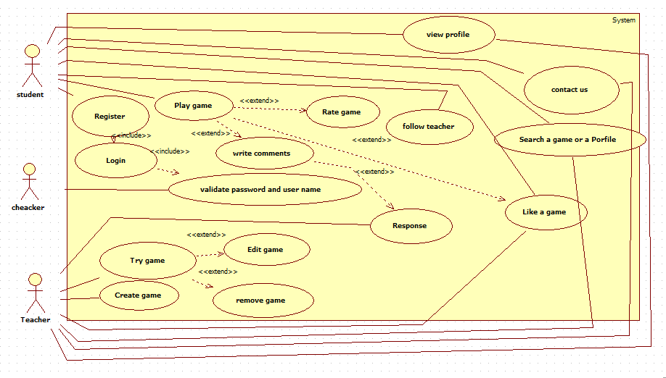

## 

## Use Case Tables

|  |  |  |
| --- | --- | --- |
| Use Case ID: | 1 | |
| Use Case Name: | Register | |
| Actors: | Student , teacher | |
| Pre-conditions: | No conditions | |
| Post-conditions: | Have an account | |
| Flow of events: | **User Action** | **System Action** |
| 1- open the application |  |
|  | 2- Enter username and Password. |
|  | 3-Enter password again. |  |
|  |  | 4-System Verify user password |
|  | 5- having an account |  |
| Exceptions: | **User Action** | **System Action** |
|  |  |

|  |  |  |
| --- | --- | --- |
| Use Case ID: | 2 | |
| Use Case Name: | Login | |
| 0Actors: | Student , teacher | |
| Pre-conditions: | Have an account | |
| Post-conditions: | register | |
| Flow of events: | **User Action** | **System Action** |
| 1- User select login or register |  |
|  | 2- System show login or register form |
|  | 3- User Enter his/her information |  |
|  |  | 4- System Verify his/her information. |
| Exceptions: | **User Action** | **System Action** |
| 1- User select login or register |  |
|  | 2- System down or username and password no matching |
| Includes: | Includes from 1 | |

|  |  |  |
| --- | --- | --- |
| Use Case ID: | 3 | |
| Use Case Name: | Create game | |
| Actors: | teacher | |
| Pre-conditions: | Login | |
| Post-conditions: | New game created | |
| Flow of events: | **User Action** | **System Action** |
| 1- Write the code of game. |  |
|  | 2- System test this code |
| 3- Design GUI for this game. |  |
| Exceptions: | **User Action** | **System Action** |
|  |  |
| Notes and Issues: |  | |

|  |  |  |
| --- | --- | --- |
| Use Case ID: | 5 | |
| Use Case Name: | Try game | |
| Actors: | Teacher | |
| Pre-conditions: | Login | |
| Post-conditions: | Try game | |
| Flow of events: | **User Action** | **System Action** |
| 1- Open the game |  |
|  | 2- System show the game |
| 3- Start to play. |  |
| Exceptions: | **User Action** | **System Action** |
|  |  |

|  |  |  |
| --- | --- | --- |
| Use Case ID: | 6 | |
| Use Case Name: | Edit game | |
| Actors: | Teacher | |
| Pre-conditions: | Try game | |
| Post-conditions: | Game edited | |
| Flow of events: | **User Action** | **System Action** |
| 1- select the game |  |
|  | 2- System open selected game |
|  | 3-edit the code or GUI |  |
|  |  | 4-Save changes |
| Exceptions: | **User Action** | **System Action** |
| Includes: | Extend from 5 | |

|  |  |  |
| --- | --- | --- |
| Use Case ID: | 7 | |
| Use Case Name: | Remove game | |
| Actors: | Teacher | |
| Pre-conditions: | Try game | |
| Post-conditions: | Game removed | |
| Flow of events: | **User Action** | **System Action** |
| 1- User select the game |  |
|  | 2- System open selected game |
|  | 3-remove game |  |
| Exceptions: | **User Action** | **System Action** |
| Includes: | Extend from 5 | |

|  |  |  |
| --- | --- | --- |
| Use Case ID: | 8 | |
| Use Case Name: | Play game | |
| Actors: | Student | |
| Pre-conditions: | register | |
| Post-conditions: | Play the game | |
| Flow of events: | **User Action** | **System Action** |
| 1- User select the game |  |
|  | 2- System open selected game |
|  | 3-user choose the game and start playing |  |
| Exceptions: | **User Action** | **System Action** |
| 1- User select the game |  |
|  | 2- game crashed |
| Includes: |  | |

|  |  |  |
| --- | --- | --- |
| Use Case ID: | 9 | |
| Use Case Name: | Rate game | |
| Actors: | Student | |
| Pre-conditions: | Play game | |
| Post-conditions: |  | |
| Flow of events: | **User Action** | **System Action** |
| 1- play the game |  |
|  | 2- select rate game button |
| 3- Rating |  |
|  |  | 4-save changes |
| Exceptions: | **User Action** | **System Action** |
|  |  |
| Includes: | Extend from 8 | |

|  |  |  |
| --- | --- | --- |
| Use Case ID: | 10 | |
| Use Case Name: | Write comment | |
| Actors: | Student | |
| Pre-conditions: | Play game | |
| Post-conditions: |  | |
| Flow of events: | **User Action** | **System Action** |
| 1- play the game |  |
|  | 2- select write comment button |
| 3- write comment |  |
|  |  | 4-save changes |
| Exceptions: | **User Action** | **System Action** |
|  |  |
| Includes: | Extend from 8 | |

|  |  |  |
| --- | --- | --- |
| Use Case ID: | 11 | |
| Use Case Name: | Response | |
| Actors: | Teacher | |
| Pre-conditions: | Student write comment | |
| Post-conditions: | Response | |
| Flow of events: | **User Action** | **System Action** |
| 1- student write comment |  |
|  | 2- show the comment |
| 3- Teacher write the response |  |
|  |  | 4-save changes |
| Exceptions: | **User Action** | **System Action** |
|  |  |
| Includes: | Extend from 10 | |

|  |  |  |
| --- | --- | --- |
| Use Case ID: | 12 | |
| Use Case Name: | Validate Password and username | |
| Actors: | Checker | |
| Pre-conditions: | login | |
| Post-conditions: |  | |
| Flow of events: | **User Action** | **System Action** |
| 1- user write his information |  |
|  | 2- system check it |
| Exceptions: | **User Action** | **System Action** |
|  |  |
| Includes: | Includes from 2 | |

|  |  |  |
| --- | --- | --- |
| Use Case ID: | 13 | |
| Use Case Name: | View Profile | |
| Actors: | Teacher, Student | |
| Pre-conditions: | login | |
| Post-conditions: |  | |
| Flow of events: | **User Action** | **System Action** |
| 1- click button search |  |
|  | 2- choose the profile |
| Exceptions: | **User Action** | **System Action** |
|  |  |
| Includes: |  | |

|  |  |  |
| --- | --- | --- |
| Use Case ID: | 14 | |
| Use Case Name: | Contact us | |
| Actors: | Teacher, Student | |
| Pre-conditions: | login | |
| Post-conditions: | Contact to the system | |
| Flow of events: | **User Action** | **System Action** |
| 1- click button contact us |  |
|  | 2- show the information about us which help you to contact with us (E-mails, Telephones …) |
| Exceptions: | **User Action** | **System Action** |
|  |  |
| Includes: |  | |

|  |  |  |
| --- | --- | --- |
| Use Case ID: | 15 | |
| Use Case Name: | Search a game or profile | |
| Actors: | Teacher, Student | |
| Pre-conditions: | login | |
| Post-conditions: |  | |
| Flow of events: | **User Action** | **System Action** |
| 1- click search button |  |
|  | 2-System show results |
|  | 3-choose the game or the profile |  |
| Exceptions: | **User Action** | **System Action** |
|  |  |
| Includes: |  | |

|  |  |  |
| --- | --- | --- |
| Use Case ID: | 16 | |
| Use Case Name: | Like a game | |
| Actors: | Student | |
| Pre-conditions: | Play a game | |
| Post-conditions: |  | |
| Flow of events: | **User Action** | **System Action** |
| 1-play the game |  |
|  | 2- show the result |
|  | 3-click on like button |  |
| Exceptions: | **User Action** | **System Action** |
|  |  |
| Includes: | Extends from 8 | |

|  |  |  |
| --- | --- | --- |
| Use Case ID: | 17 | |
| Use Case Name: | Follow teacher | |
| Actors: | Teacher | |
| Pre-conditions: | Have an account | |
| Post-conditions: |  | |
| Flow of events: | **User Action** | **System Action** |
| 1- search a profile of a teacher |  |
|  | 2- system show the account |
|  | 3-click follow button |  |
|  |  | 4-the follow button turned to followed |
| Exceptions: | **User Action** | **System Action** |
|  |  |
| Includes: |  | |

# 

# Ownership Report

|  |  |
| --- | --- |
| **Item** | **Owners** |
|  | *muhammad rashaad Elsayed* |
|  | *Ahmed Sherif Zain* |

Github link : https://github.com/towhere?tab=repositories